**Project Report**

**DBMS**

***Inventory Management System***

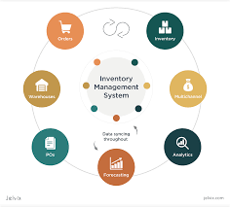

**Introduction**

**Project Description:**

In this InventoryManagement System the super powers are with the admin that can access all features of the management system like categories,products,media and sales areas.Other user and employee are restricted in their domain by allowing them to view what they are required.

**Problem Statement:**

Today retail sellers don't have solution to keep track of inventory. Hence a B2B solution is required in order to place online orders, keep track, cycle counting and categorization of products etc.

Inventory management

The module or feature&#39;s primary goal is to keep your warehouse&#39;s core operations

concentrated. This makes it easier to keep track of all inventory information, including

stock level, product history, and other product characteristics. More crucially, the data

synchronises with the other inventory system components. This facilitates correct

inventory management, which raises productivity by encouraging team members

working remotely on their systems to collaborate.

● Stock management

● Categorization

● Vendor Management

● Inventory/Product History

● Inventory Alerts

● Accounting Tools

● User Profile Management

● Add/Remove Products Data

● Modify Product Data

Reporting Tools

For any inventory business to be effective, you must be informed in real-time about the

state of the products, the location of the drivers, the status of the orders, the status of

the shipments, and much more. An effective inventory management app has the ability

to incorporate several reporting tools and features, which simplifies the reporting

process. This is an essential component of any serious inventory business.

● Reporting Tools

● Enhanced Productivity

● Smooth Communication

● Stock Return Handling

Reporting Tools

Vendors or retailers can place their inventory order online and keep track of the

inventory to make sure they donot disappoint the customer with the excuse of

unavailability.

● Account creation

● Order Placement

● Product Catalogue By Company/Category

This system will help boost performance and efficiency of the small scale retailers.

**DATA BASE MANAGMET SYSTEM:**

A database management system (DBMS) is system software for creating and

managing databases.

A database management system (DBMS) is system software for creating and

managing databases.

A database management system (DBMS) is system software for creating and

managing databases.

A database management system (DBMS) is system software for creating and

managing databases.

A database management system (DBMS) is system software for creating and

managing databases.

A database management system (DBMS) is system software for creating and

managing databases.

A database management system (DBMS) is system software for creating and

managing databases.

A database management system (DBMS) is system software for creating and

managing databases.

A database management system (DBMS) is system software for creating and

managing databases.

A database management system (DBMS) is system software for creating and

managing databases.

A database management system (DBMS) is system software for creating and

managing databases.

A database management system (DBMS) is system software for creating and

managing databases.

A database management system (DBMS) is system software for creating and

managing databases.

A database management system (DBMS) is system software for creating and

managing databases.

DBMS is the system software for creating and managing the data. DBMS manage three things data, DB engine that allow data to accessed, and DB Schema.

**MY SQL:**

MySQL is a relational database management system (RDBMS) developed by Oracle that is based on structured query language (SQL).

database’s logical structure. These three foundational elements help to provide

concurrency, security, data integrity and uniform administration procedures. Typical

database administration tasks supported by the DBMS include change management,

performance monitoring/tuning and backup and recovery. Many database

management systems are also responsible for automated rollbacks, restarts and

recovery as well as the logging and auditing of activity.

**1.4 SQL**

SQL is a standard language for storing, manipulating and retrieving data in databases.

Originally based upon relational algebra and tuple relational calculus, SQL consists of

a data definition language, data manipulation language, and data control language.

The scope of SQL includes data insert, query, update and delete, schema creation and

modification, and data access control.

SQL became a standard of the American National Standards Institute (ANSI) in 1986,

and of the International Organization for Standardization (ISO) in 1987.Since

then, the standard has been revised to include a larger set of features. Despite the

existence of such standards, most SQL code is not completely portable among

different database systems without adjustments.

**1.5 HTML / JavaScript**

Database’s logical structure. These three foundational elements help to provide

concurrency, security, data integrity and uniform administration procedures. Typical

database administration tasks supported by the DBMS include change management,

performance monitoring/tuning and backup and recovery. Many database

management systems are also responsible for automated rollbacks, restarts and

recovery as well as the logging and auditing of activity.

**1.5 PHP**

Html is markup language used for structuring content on web and fifth and current major version of HTML standard

PHP(short for Hypertext PreProcessor) is the most widely used open source and general purpose server side scripting language used mainly in web development to create dynamic websites and applications.

**Requirements specification**

**Software Requirement:**

* **XAMP**
* **PHP MYADMIN**
* **VS-CODE**
* **ORACEL**
* **OS WINDOWS**
* **LOCAL HOST**

**Hardware Requirement:**

* **RAM**
* **SSD**

**Technology:**

* Html is used for frontend design
* Css is style sheet language used for describing the presentation of document
* MySQL is a relational database management system (RDBMS) developed by Oracle that is based on structured query language (SQL).
* PHP(short for Hypertext PreProcessor) is the most widely used open source and general purpose server side scripting language used mainly in web development to create dynamic websites and applications.

**Detailed Design**

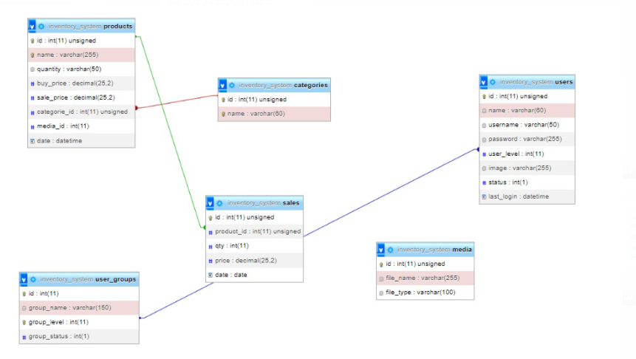

**ER-Diagram:**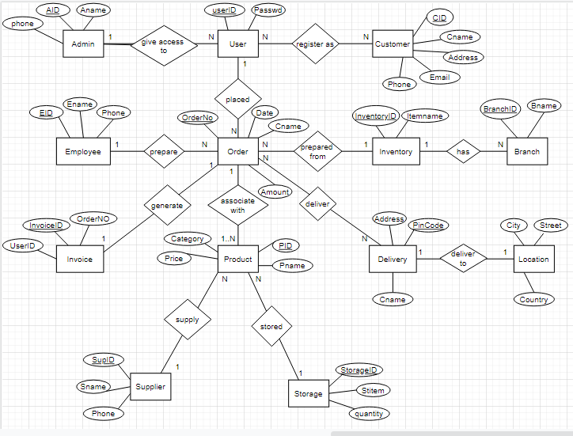

**Front view of my project:**

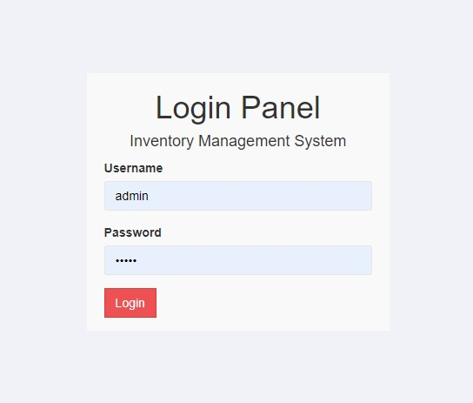

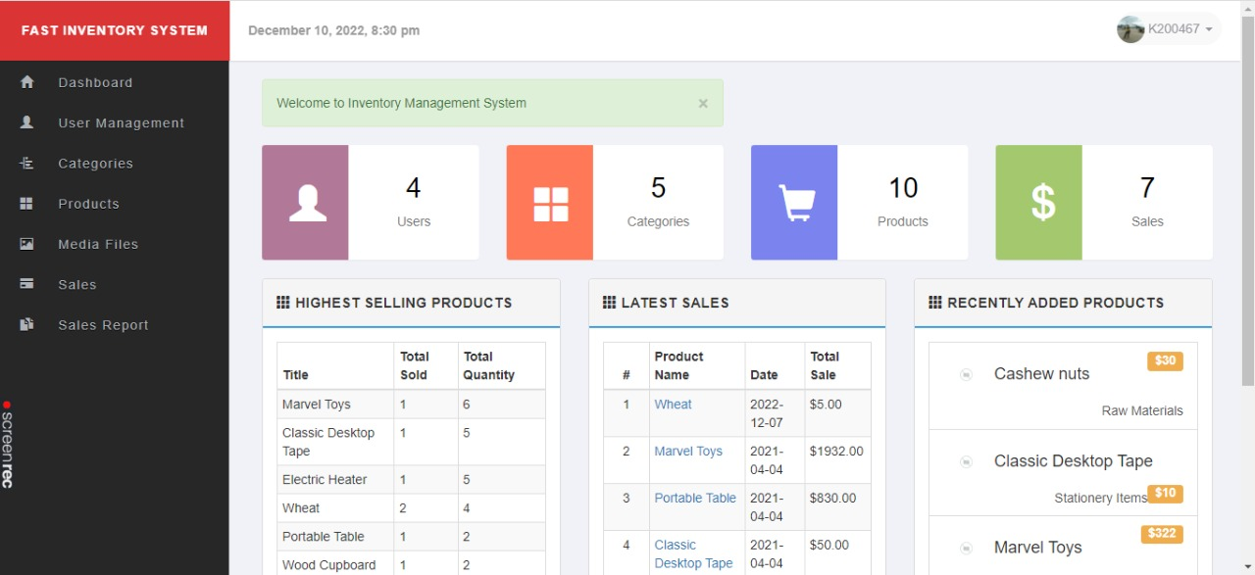

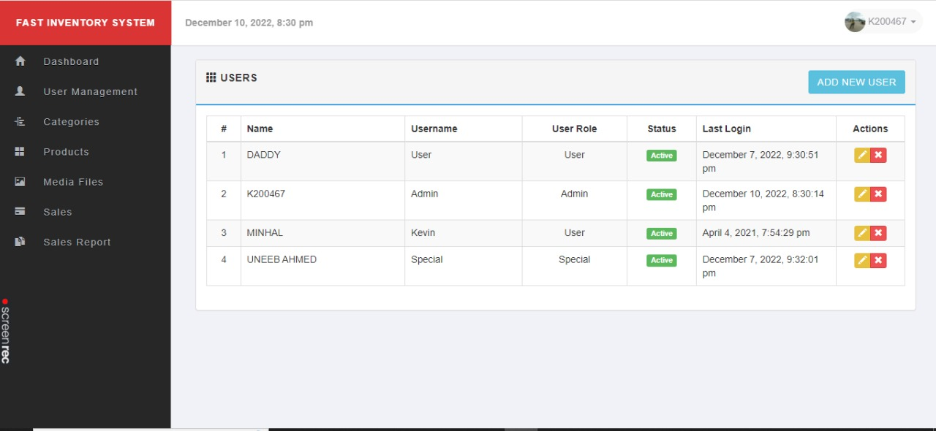

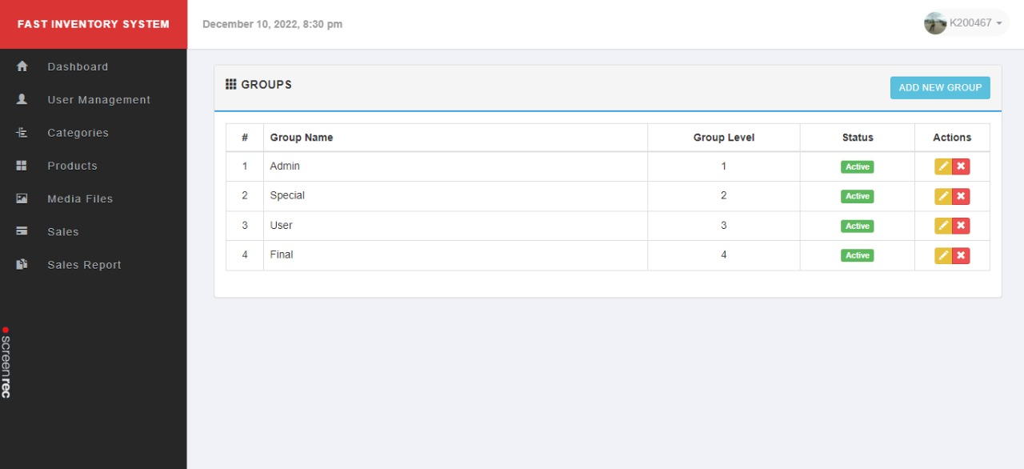

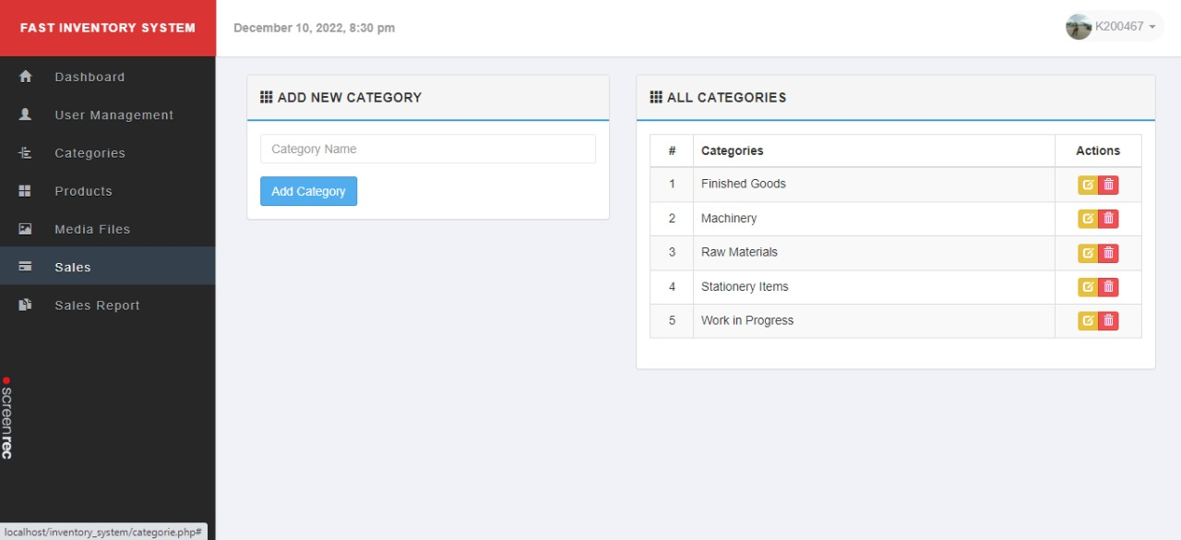

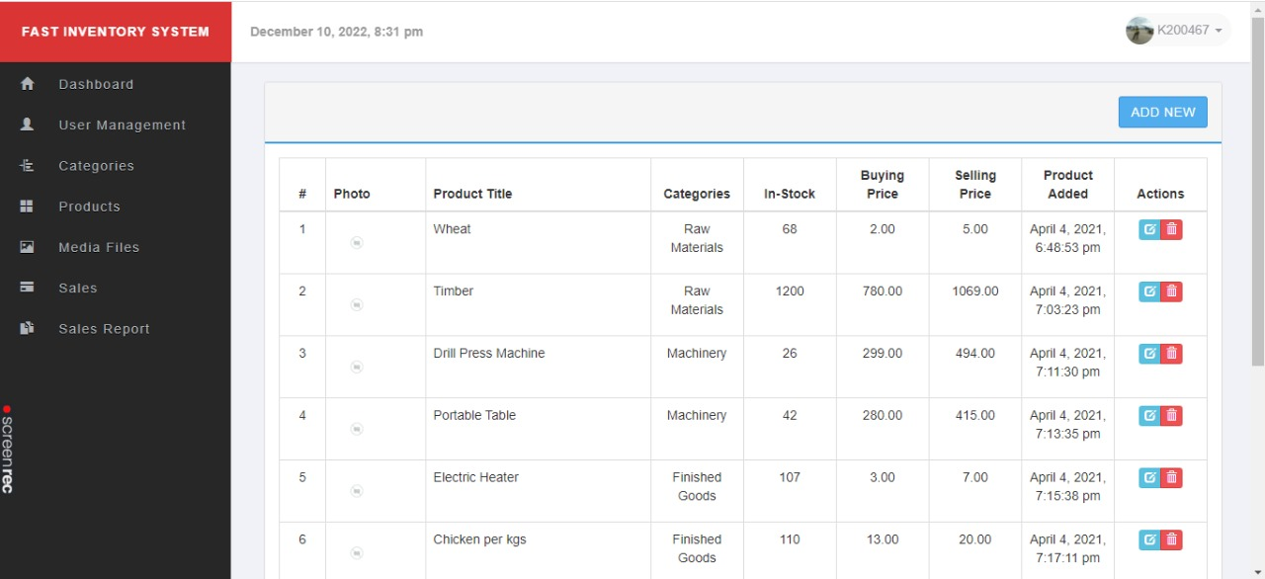

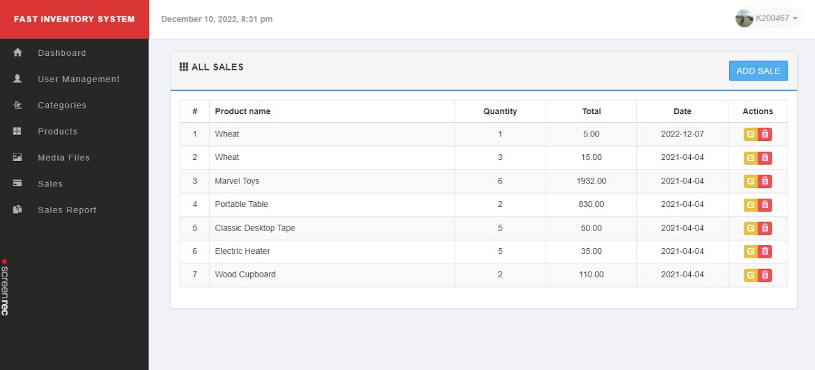

**Description of Table:**

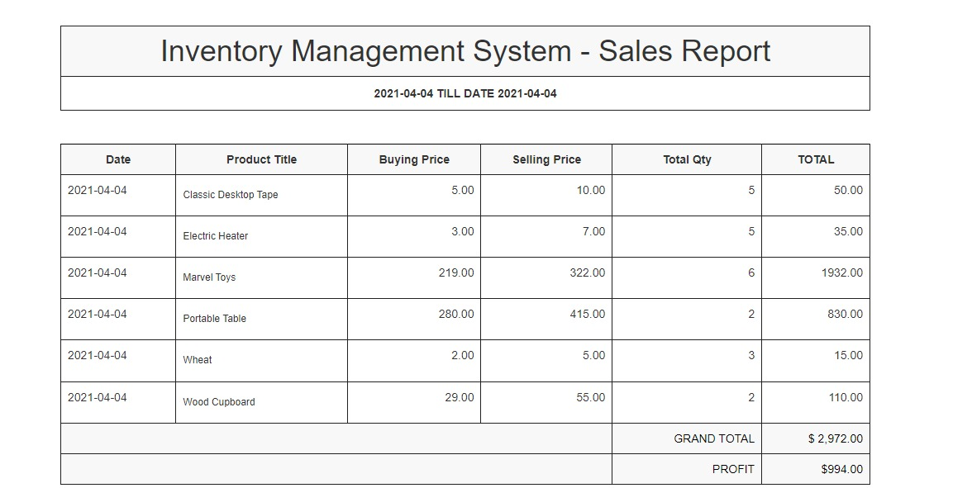

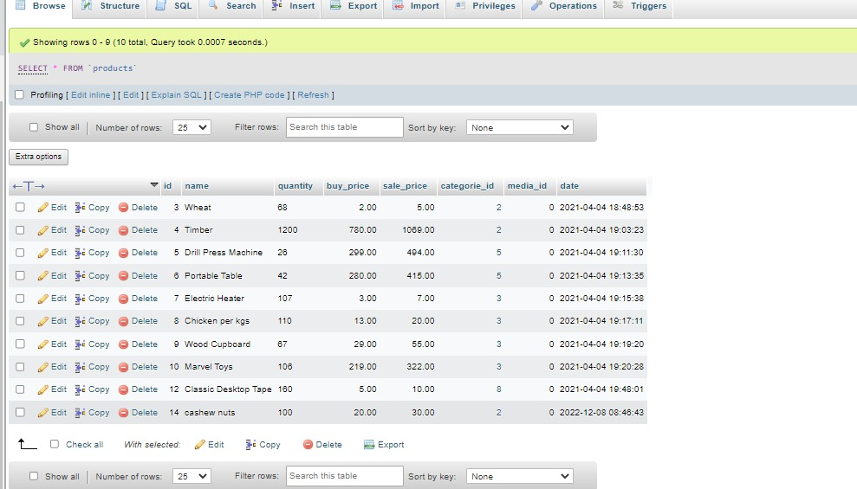

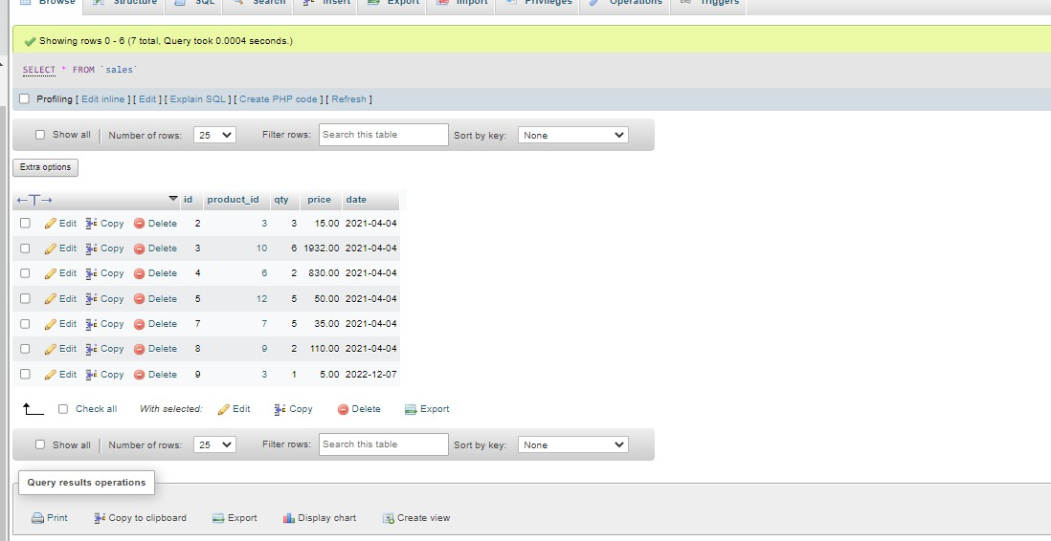

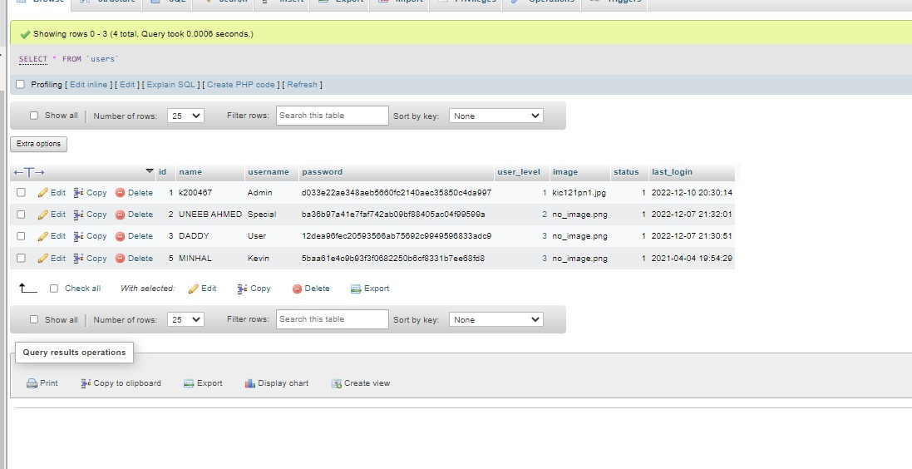

**Class Diagram:**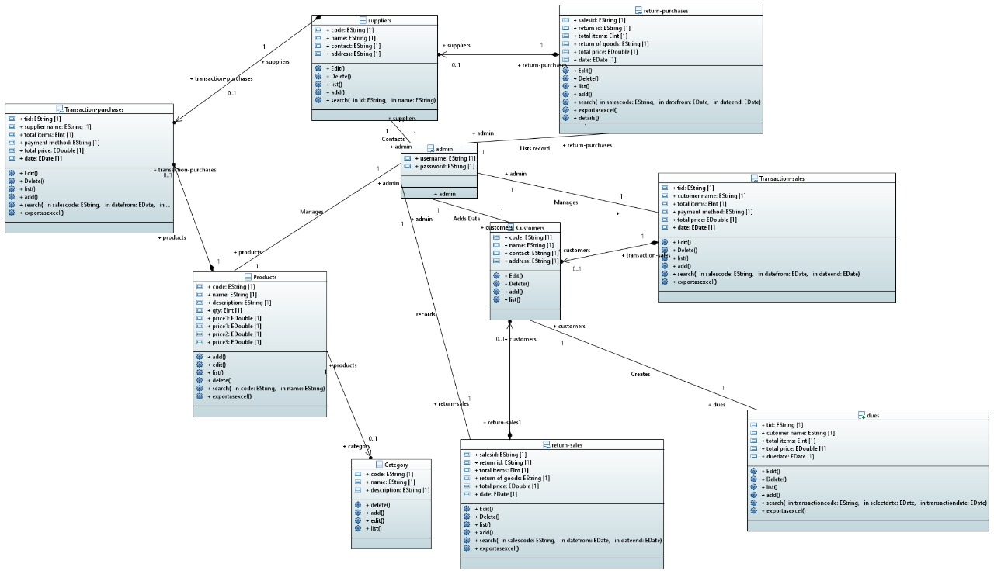

**Implementation Code Snippets**

**Adding new user:**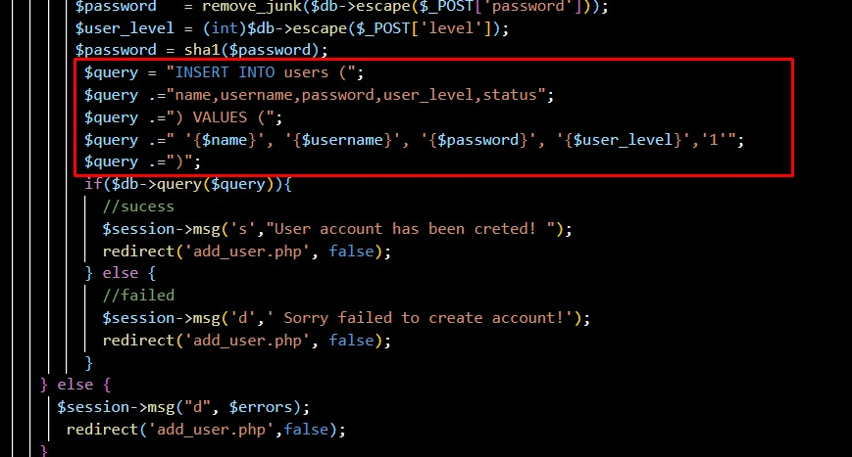

**Adding user groups:**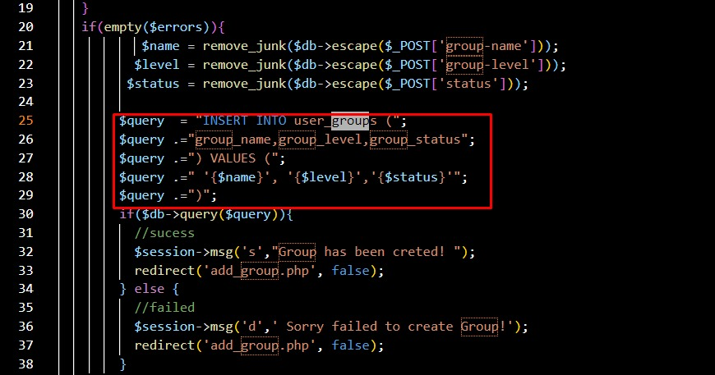

**Authentication:**

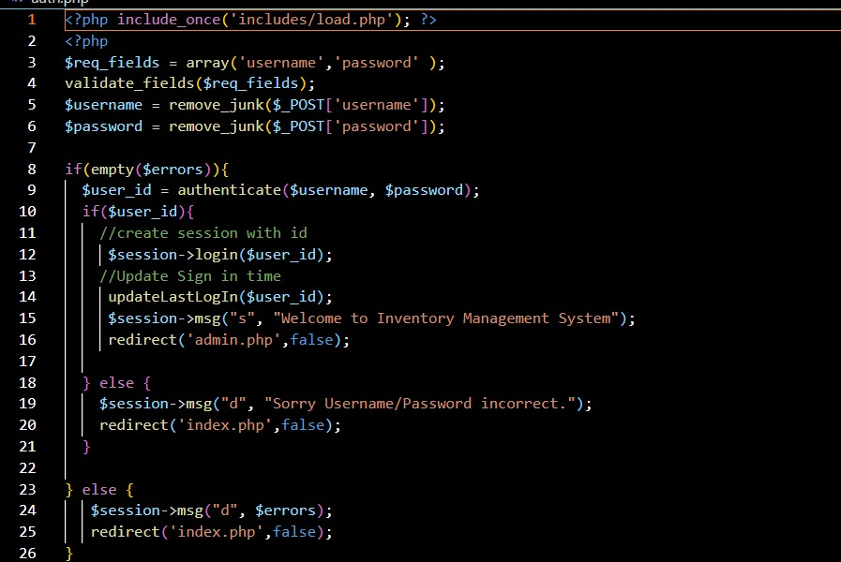

**Adding categories:**

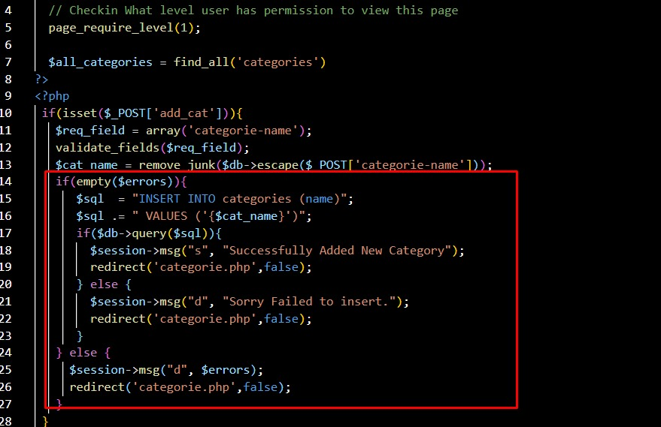

**Checking recent products:**

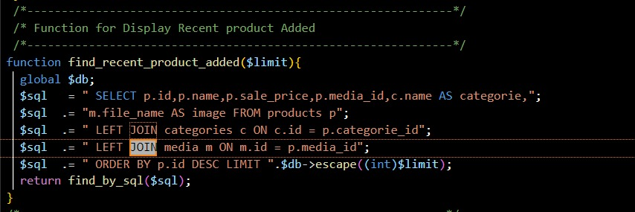

**Update user pwd:**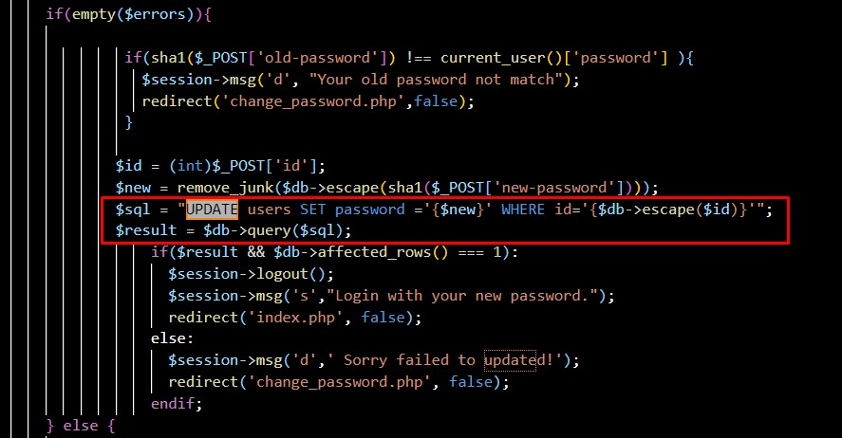

**Create:**

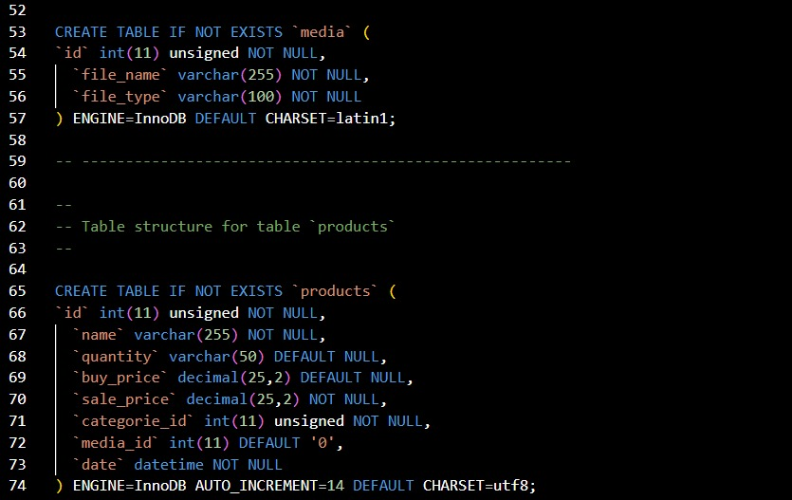

**Insert:**

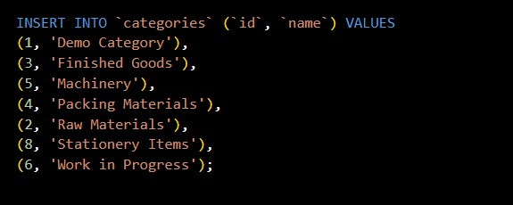

**Alter:**

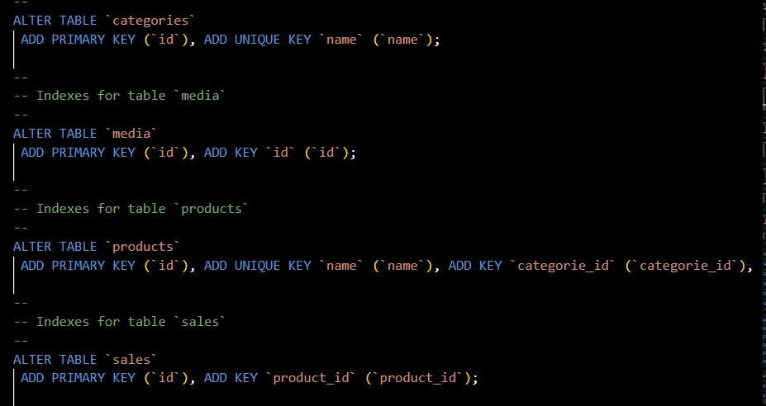

**Modify:**

